Basketball Camp 
● South Woodside CAP Association is holding a basketball camp on these dates: July 26 -30, August 3-6, 9-13, 16-20, 23-27
● The Camp Runs for an Hour Each Morning from 9am-10am.
● The Camp will be put on by Chad Smith.
● The Cost Of The Camp is: $25/ Week or $85 for All 5 Weeks.
● Each Week Is A Completely Different Camp!!!
About Chad:
● Dalhousie Varsity Basketball Team Member
- Under 17 National Championships Silver Medalist
- 3 Time Nova Scotia Under 17 Provincial Team Member
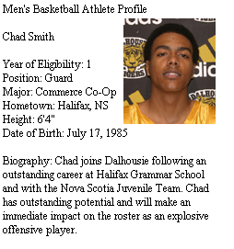


Connecting You to a World Full of Information.

South Woodside CAP
5 Everette St.
Dartmouth, NS B3S 1L7
Phone: (902) 494-2329
Fax: (902) 494-2329
Swcap1@chebucto.ns.ca

South Woodside Cap

