#### C:\Users\Owner\Pictures\society logo.bmpCanadian National Convention Memories



**1978 Edmonton, Alberta**

6400 dancers met together in Canada for the first time. A contingent of Nova Scotians in tartan and yellow successfully bidding for the 3rd Canadian National.

Freddy makes his debut. Tales about a sea of mud in the campground.

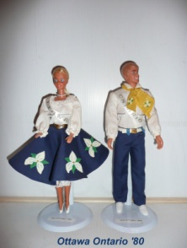

**1980 Ottawa, Ontario**

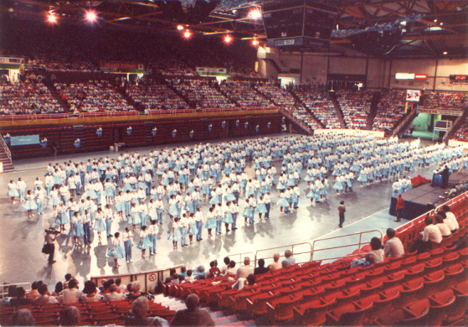 Dancing on the Hill following the changing of the guard on a sunny and hot morning amid a sea of Ontario dancers in royal blue with white Trilliums. Saskatchewan skirts with orange lilies and New Brunswick skirts with purple violets. Plus dancing in the Coliseum Building at Lansdowne Park with gigantic open doors bringing in hot and steamy breezes between thunderstorms.

**1982 Halifax, Nova Scotia – “C U in 82”**

Sky blue and white sailor outfits filling the Metro Centre to welcome our visitors. Dancing at historic properties in the ocean breeze. Buses between Metro Centre, St. Pat’s and Queen Elizabeth High Schools and the Lord Nelson Hotel. Balloons in the ceiling of the Metro Centre shaped like a map of Nova Scotia. Elation knowing that we had achieved our goal!

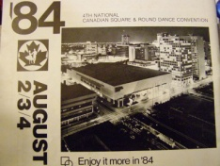

**1984 Winnipeg, Manitoba – “Enjoy it more in ‘84”**

Dancing for the first time all under one roof in the Winnipeg Convention Centre.

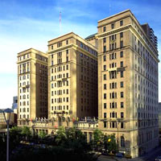

**1986 Calgary, Alberta – “Saddle up for Calgary”**

Red pants and white cowboy hats. A fire alarm closing the elevators and hiking down multiple floors in the hotel. Over 6000 dancers in the Convention Centre, the Arts Centre, and in the venerable Palliser Hotel.

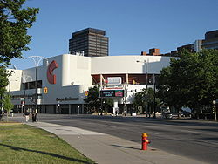

**1988 Hamilton, Ontario – “Hub of the Golden Horseshoe”**

Black balloons decorating Copps Coliseum. Teens climbing over the railing to join the opening ceremony dancing and stealing the show. Temperatures over 100 degrees closing down all dance areas that were not air-conditioned.

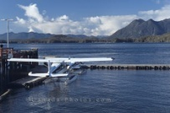

**1990 Vancouver, British Columbia – “Coast into Vancouver”**

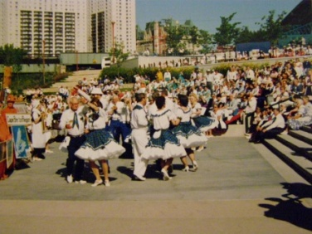 Revelling in our largest attendance to date with 6650 dancers greeting and twirling in every hall under the white sails of Canada Place. Float planes taking off just outside the enormous A2 hall that echoed back every call.

**1992 Winnipeg, Manitoba – “It’s What to Do in ‘92”**

Presenting Nova Scotia's "Dance by the Shore” promo at the confluence of the Assiniboine and Red Rivers on a beautiful and cool sunny morning. Enjoying the meeting of east and west in this historical prairie trading post.

Canadian National Convention Memories

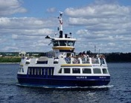

**1994 Halifax, Nova Scotia – “Dance By the Shore in ‘94”**

Dancing by the shore on each side of the harbour and riding the ferry across. Banner Parade walking around Citadel Hill. Nova Scotians in tartan, white, and royal blue outfits. Live fiddle music for the opening dance.

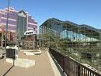

**1996 Edmonton, Alberta – “Alberta Bound”**

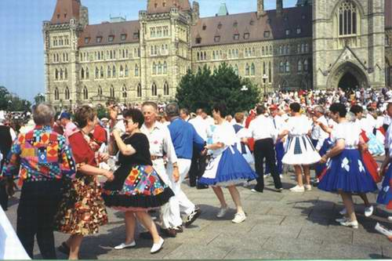 Alberta wild roses decorating the halls. Klondike outfits with green suspenders. Dancing in the lovely tiered and glass enclosed Shaw Conference Center along the banks of the North Saskatchewan River.

**1998 Ottawa, Ontario – “A Capital Convention”**

Tulips of many colors displayed on skirts and walls. Dancing (and calling) on the hill after the changing of the guard during a very hot morning. Eating lunch below the convention center on the banks of the Rideau Canal.

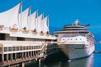

**2000 Vancouver, British Columbia – “Sail Into the Century”**

Complications from striking hotel staff. Sharing a tiny and expensive room in the Pan Pacific with a spectacular view across Burrard Inlet and looking down on Alaska cruise ships. Chinese Dragon dancers before the 2002 song and dance.

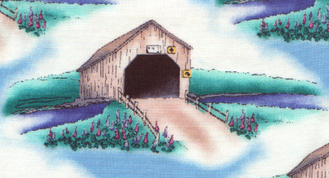**2002 Saint John, New Brunswick – “The Place for You in Twenty-0-Two”**

It was a waterless Wednesday when the water mains broke. Covered Bridges in a field of Lupines designed on specially commissioned material. “Come on Down” dance combining rounds, squares and traditional figures.

Enjoying a Calgary breakfast by the waterfront and earning a “Yahoo” dangle.

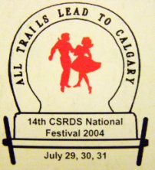

**2004 Calgary, Alberta – “All Trails Lead to Calgary”**

Cowboy hats. Chuck wagons leaving road apples. Being lost in the maze of rooms inside the Calgary Convention Center. Montreal’s intricate traditional Quebec quadrille with awesome weaving of woollen belts.

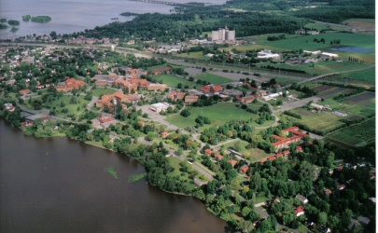

**2006 Montreal, Quebec – “Let’s All Mix in 2006”**

Eating in small restaurants in the delightful town of Sainte Anne Du Bellevue. Driving the scenic route along the St. Lawrence River back to our hotel. Dancing in John Abbott College and Macdonald High School with one cool building and two very hot buildings. Closing ceremonies featuring a wonderful demonstration of energetic 19th century ballroom dancing.

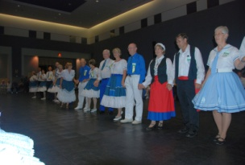

**2008 London, Ontario – “Make a Date for 2008”**

Callerlab Mini-Meeting before the Convention and Callerlab Board Members calling at the Trail in Dance. Ragtime band playing in the foyer. Fluorescent colours on black light dancers performing to Sukiyaki. Black tile click flooring. Saturday ice sculpture. Standing ovation for the Nova Scotia Promo and Heritage Dance. Closing song encouraging all to “Meet again in Halifax in 2010”.